- First created a ubuntu machine with ts small
- Opened the vscode inside a terraform folder
- Terraform basically consists of three layer and two layer objects
- The three layer object looks like
Resource “ resource name as defined by terraform” “ local resource identification name” {
Arguments…….
}
- The two tyre object looks like
Objectname “ name defined by terraform” {
}

For aws instance see the documentation

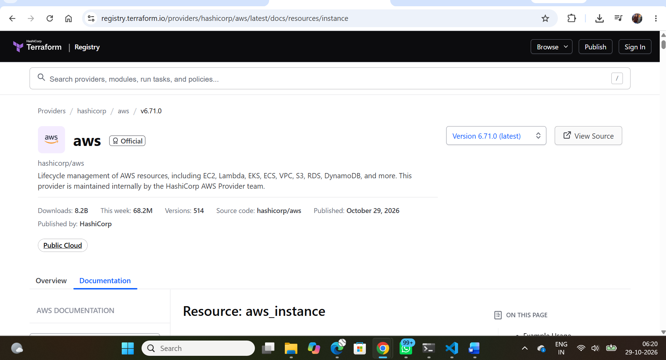

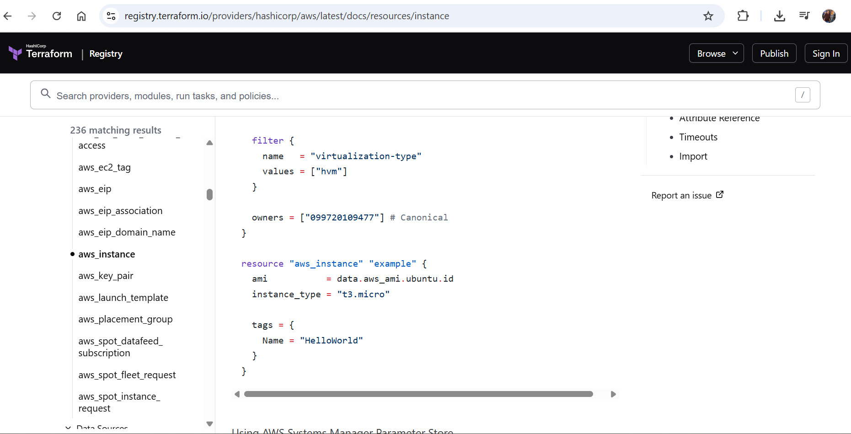

- Now we have to install the terraform on the EC2 instance
Go to documentation install terraform on ubuntu
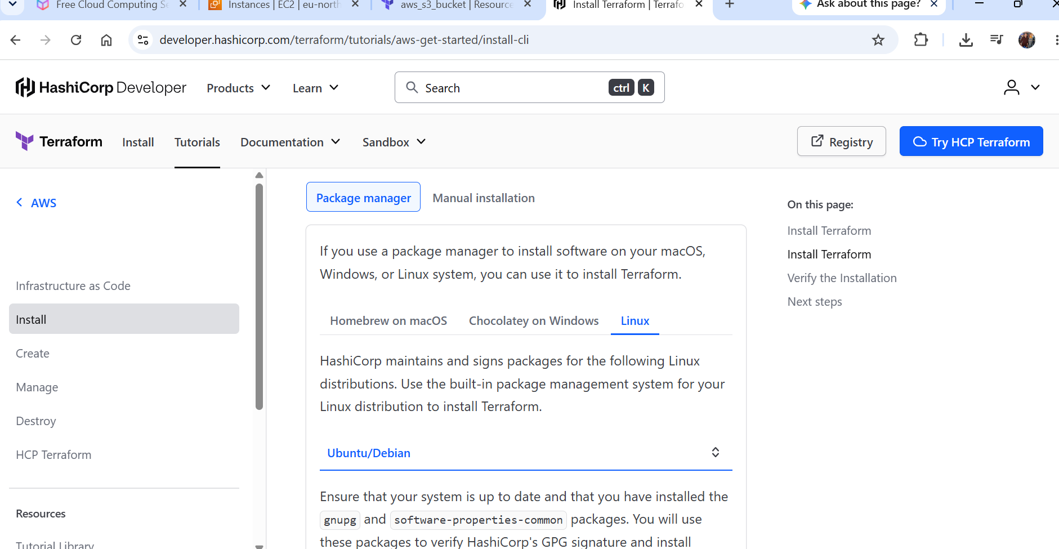

Select package manager, Debian

Now installing terraform on ubuntu ec2 machine

sudo apt-get update && sudo apt-get install -y gnupg software-properties-common

wget -O- https://apt.releases.hashicorp.com/gpg | \
gpg --dearmor | \
sudo tee /usr/share/keyrings/hashicorp-archive-keyring.gpg > /dev/null

gpg --no-default-keyring \
--keyring /usr/share/keyrings/hashicorp-archive-keyring.gpg \
--fingerprint

echo "deb [arch=$(dpkg --print-architecture) signed-by=/usr/share/keyrings/hashicorp-archive-keyring.gpg] https://apt.releases.hashicorp.com $(grep -oP '(?<=UBUNTU_CODENAME=).*' /etc/os-release || lsb_release -cs) main" | sudo tee /etc/apt/sources.list.d/hashicorp.list

sudo apt update

sudo apt-get install terraform

terraform version
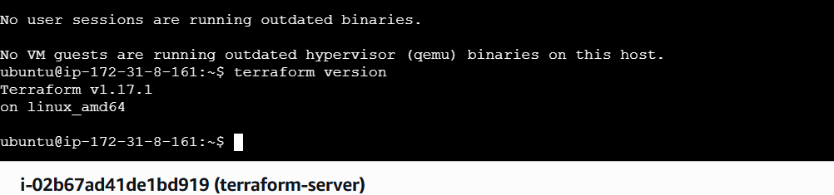

Go to https://github.com/hashicorp/terraform
For github terraform (it tells and informs about latest updates and all)

Now we start first terraform file main.tf

